**Semester 2 (Units 3 and 4) Examination, 2019**

**Question/Answer Booklet**

**MATHEMATICS APPLICATIONS**

**Section Two: Calculator-assumed**

Student Name/Number: ______________________________________________

Teacher Name: ______________________________________________

**Time allowed for this section**

Reading time before commencing work: ten minutes

Working time: one hundred minutes

**Materials required/recommended for this section**

***To be provided by the supervisor:***

This Question/Answer Booklet

Formula Sheet (retained from Section One)

***To be provided by the candidate:***

Standard items: pens (blue/black preferred), pencils (including coloured), sharpener,

correction fluid/tape, eraser, ruler, highlighters

Special items: drawing instruments, templates, notes on two unfolded sheets of A4 paper, and up to three calculators approved for use in the WACE examinations

**Important note to candidates**

No other items may be taken into the examination room. It is **your** responsibility to ensure that you do not have any unauthorised material. If you have any unauthorised material with you, hand it to the supervisor **before** reading any further.

**Structure of this paper**

|  |  |  |  |  |  |
| --- | --- | --- | --- | --- | --- |
| Section | Number of questions available | Number of questions to be answered | Working time (minutes) | Marks available | Percentage of exam |
| Section One: Calculator-free | 6 | 6 | 50 | 50 | 35 |
| Section Two: Calculator-assumed | 11 | 11 | 100 | 102 | 65 |
|  | | | | | 100 |

**Instructions to candidates**

1. The rules for the conduct of School exams are detailed in the *_______________________________________School/College assessment policy*. Sitting this examination implies that you agree to abide by these rules.
2. Write your answers in this Question/Answer booklet preferably using a blue/black pen. Do not use erasable or gel pens.
3. You must be careful to confine your answer to the specific question asked and to follow any instructions that are specified to a particular question.
4. Show all your working clearly. Your working should be in sufficient detail to allow your answers to be checked readily and for marks to be awarded for reasoning. Incorrect answers given without supporting reasoning cannot be allocated any marks. For any question or part question worth more than two marks, valid working or justification is required to receive full marks. If you repeat any question, ensure that you cancel the answer you do not wish to have marked.
5. It is recommended that you do not use pencil, except in diagrams.
6. Supplementary pages for planning/continuing your answers to questions are provided at the end of this Question/Answer booklet. If you use these pages to continue an answer, indicate at the original answer where the answer is continued, i.e. give the page number.
7. The Formula sheet is not to be handed in with your Question/Answer booklet.

**Section Two: Calculator-assumed 65% (102 Marks)**

This section has **eleven** **(11)** questions. Answer **all** questions. Write your answers in the spaces provided.

Supplementary pages for the use of planning/continuing your answer to a question have been provided at the end of this Question/Answer booklet. If you use these pages to continue an answer, indicate at the original answer where the answer is continued, i.e. give the page number.

Working time: 100 minutes.

**Question 7 (6 marks)**

A house renovation team needs to complete the following tasks.

* Cleaning, Painting, Plumbing, Tiling and Paving

James will do any of the five tasks. Mary will only do cleaning and painting. Jennifer is happy to do plumbing or tiling and Peter will do anything except plumbing and paving.

1. Complete the graph below to represent the information provided. (3 marks)

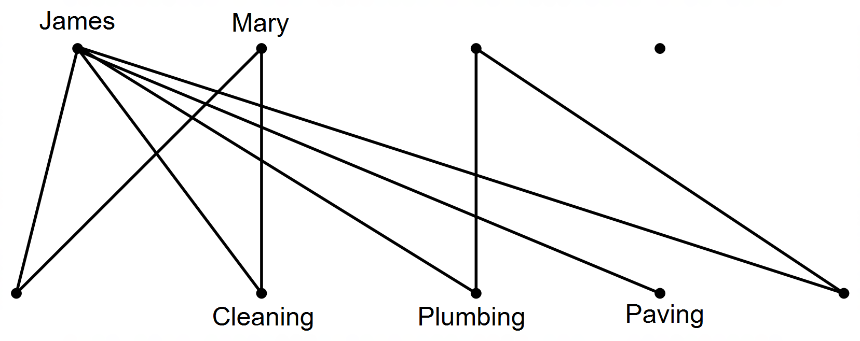

1. What name is given to the type of graph have you drawn?

Justify why it is an appropriate graph to represent the information provided. (3 marks)

**Question 8 (10 marks)**

A community group are conducting a long term project on the rehabilitation of the Carnaby Cockatoo population in the Alkimos area. The project commenced at the beginning of 2013, when the population size was 3500. The population numbers were then recorded at the start of each year for the next 5 years. The results indicate a first-order recurrence relationship modelled by



(a) Complete the table and graph below: (5 marks)

|  |  |  |  |  |  |  |
| --- | --- | --- | --- | --- | --- | --- |
|  | 0 | 1 | 2 | 3 | 4 | 5 |
| Population size (00s) | 35 |  |  |  |  |  |

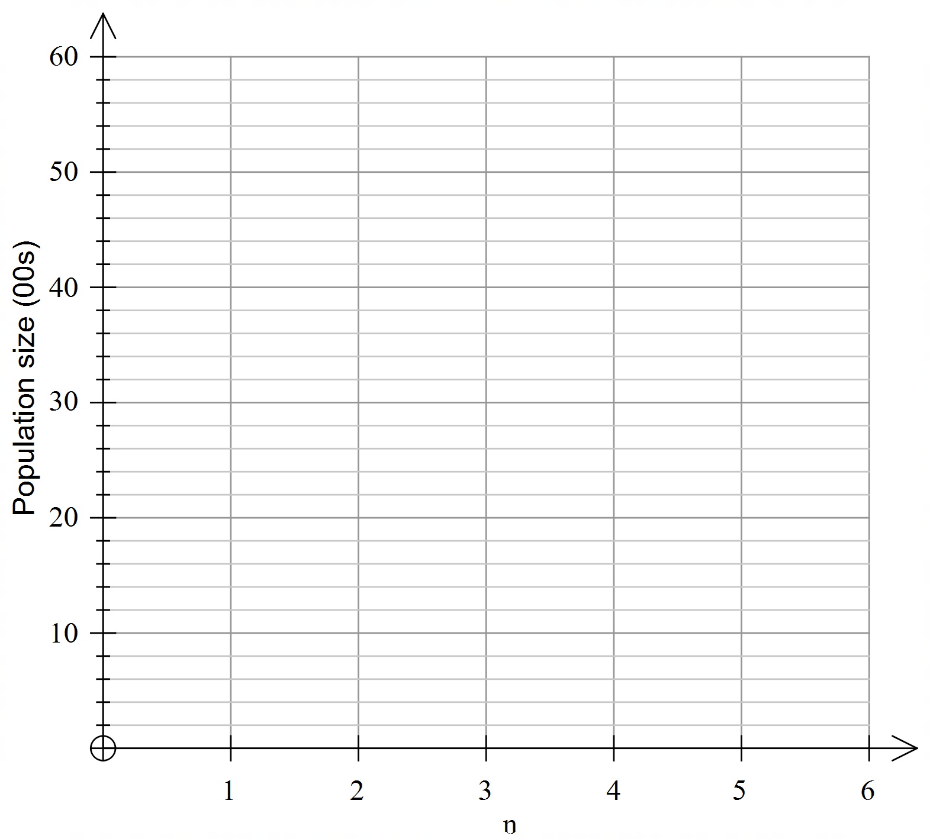

(b) Comment on the trend of the cockatoo population. (2 marks)

(c) The Department of Environmental Protection will change the status from endangered to vulnerable when the population reaches 6000. Will the Carnaby Cockatoos reach this status? Justify your answer.

(3 marks)

**Question 9 (12 marks)**

Jennifer borrows $40 000 from a financial institution to buy a new car. The interest rate is 12% per annum, reducible monthly, and the repayment schedule is tabulated below.

|  |  |  |  |
| --- | --- | --- | --- |
| Repayment | Interest ($) | Monthly repayment ($) | Amount Owing |
| 1 | 400 | 1000 | 39400 |
| 2 | 394 | 1000 | 38794 |
| 3 | 387.94 | 1000 | 38181.94 |
| 4 | A | B | C |
| … |  |  |  |
| 10 | 343.79 | 1000 | 33722.67 |
| 11 | 421.53 | 1000 | 32644.21 |
| 12 | 408.05 | 1500 | 31552.26 |
| … |  |  |  |
| 36 | 28.76 | 1500 | 829.84 |
| 37 | D | E | 0 |

(a) After the tenth repayment has been made, the terms of the repayment contract stipulate that the interest rate increases. Calculate the new interest rate. (2 marks)

(b) Calculate the missing values of A, B, C, D and E. (5 marks)

(c) Write a recursive formula that can be used to determine the amount of the loan at the end of each month for the first ten repayments. (3 marks)

(d) Calculate the total amount of interest Jennifer paid. (2 marks)

**Question 10 (5 marks)**

Michael wishes to invest $20 000 into a term deposit savings account for 10 years. He has narrowed his investment options to:

Option 1: Simple interest at 12.5% per annum

Option 2: 10.75% p.a. compounded quarterly

Option 3: 9.50% p.a. compounded weekly

Which investment option should Michael select? Justify your decision.

**Question 11 (6 marks)**

The table below shows all the direct paths, in metres, between several buildings at a school. The school wishes to build verandahs over some of the paths to provide cover from the rain when students are travelling from class to class. They have a limited budget, so need to complete the minimum amount required to join all classes.



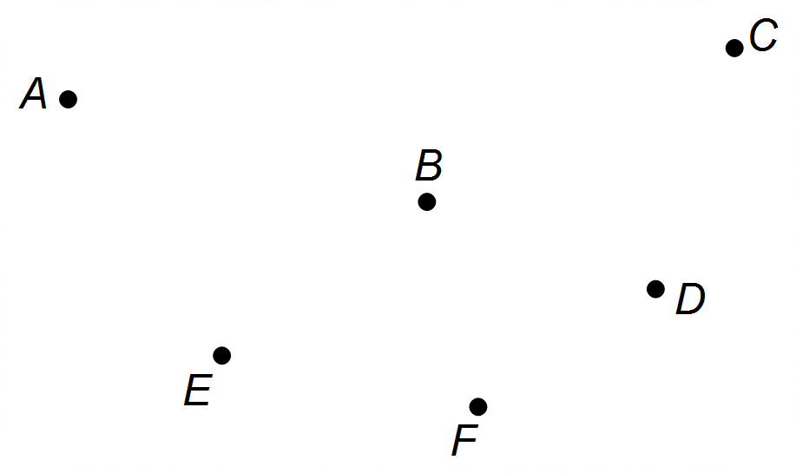

|  |  |  |  |  |  |  |
| --- | --- | --- | --- | --- | --- | --- |
|  | **A** | **B** | **C** | **D** | **E** | **F** |
| **A** | - | 8.5 | 12.5 | - | 8.7 | - |
| **B** | 8.5 | - | 7.6 | 6.2 | 4.5 | - |
| **C** | 12.5 | 7.6 | - | 6.4 | - | 8.8 |
| **D** | - | 6.2 | 6.4 | - | 5.8 | 3.1 |
| **E** | 8.7 | 4.5 | - | 5.8 | - | 6.8 |
| **F** | - | - | 8.8 | 3.1 | 6.8 | - |

(a) Use Prim’s algorithm to find and then draw the minimum spanning tree.

(2 marks)

(b) If the new verandah can be installed at a cost of $840 per metre, calculate the minimum cost. (2 marks)

(c) Due to special needs of one student, there must be a direct undercover path from *B* to *C*. What effect does this have on your minimum cost? (2 mark)

**Question 12 (15 marks)**

The graph below shows the daily petrol price (per litre) for unleaded petrol (ULP) at a particular metropolitan fuel outlet for the first three weeks of October 2017. Day 1 is Sunday 1st October.

(a) What moving point average would be the most suitable for the data displayed in the graph, and why? (2 marks)

(b) Describe the trend displayed by the graph. (2 marks)

The table below shows the price (in cents per litre) for days 4 to 14.

|  |  |  |  |  |  |  |  |  |  |  |  |
| --- | --- | --- | --- | --- | --- | --- | --- | --- | --- | --- | --- |
| Day number | 4 | 5 | 6 | 7 | 8 | 9 | 10 | 11 | 12 | 13 | 14 |
| Price/litre | 127.5 | 125.9 | 121.0 | 130.4 | 131.0 | 131.1 | 130.4 | 129.0 | 126.9 | 123.8 | 131.5 |

(c) Calculate the percentage of the weekly mean for days 9 and 10. (4 marks)

(d) For days 4 to 21, the equation of the least-squares line for the moving average price (******) against the number of days (******) since 1st October 2017 is 

Draw this line on the graph. (3 marks)

(e) Given that day 25 is a Wednesday and that the seasonal index for Wednesdays is , calculate the price per litre, for Wednesday 25th October. (2 marks)

(f) Comment on the reliability of your prediction made in part (e). (2 marks)

**Question 13 (10 marks)**

Passengers travelling from Butler (*B*) to Midland (*M*) need to cross several platforms at Perth Underground Station. The different routes consisting of lifts, stairs, escalators and footpaths are displayed on the network below. The weights of the edges represent the maximum number of people per minute that can safely pass through.

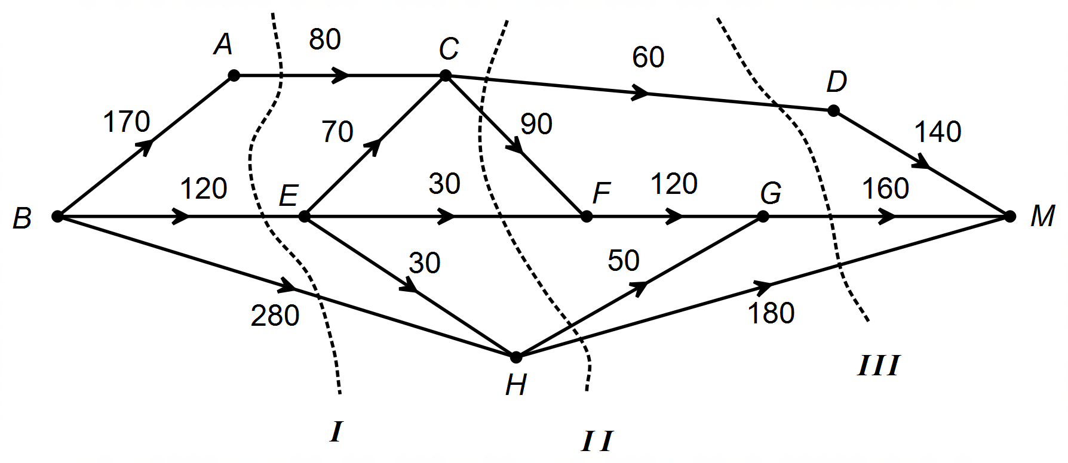

(a) Determine the maximum number of people that can cross through the network from *B* to *M* every minute. (4 marks)

(b) There are 3 cuts, labelled   and 

Calculate their totals and select the one that shows maximum flow from *B* to *M.* (3 marks)

(c) The Department of Transport are looking to upgrade the two lifts that currently carry 30 people per minute, to 50 people per minute. Explain the effect it will have on the maximum flow. (3 marks)

**Question 14 (8 marks)**

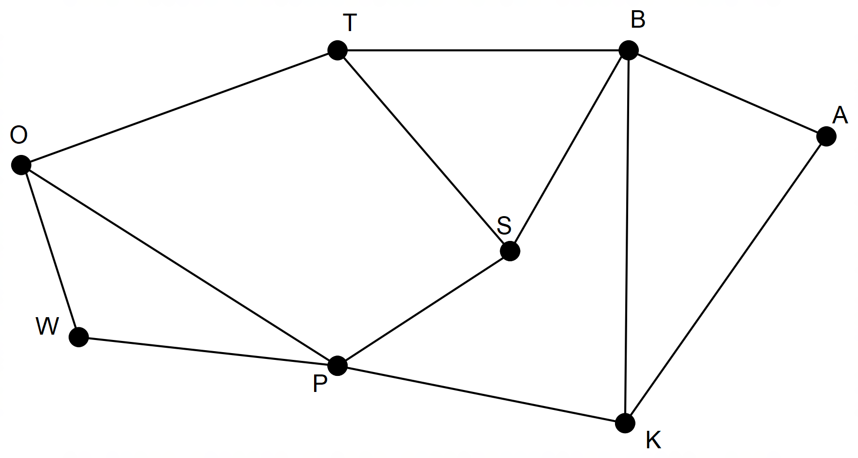The graph below shows the tracks connecting key observation points that are part of an orienteering circuit.

(a) By identifying the number of regions (faces), edges and vertices, verify that Euler’s formula applies to this network. (4 marks)

1. Can the above graph be identified as Eulerian? If so, explain why it is so, and if not explain why not? (2 marks)
2. Mark the walk POTBSP on the diagram above. What special name came be given to this walk and what are it’s defining characteristics? (3 marks)

**Question 15 (14 marks)**

The heights and masses of a group of 20 students are displayed below.

|  |  |  |  |  |  |  |  |  |  |  |
| --- | --- | --- | --- | --- | --- | --- | --- | --- | --- | --- |
| **Height (cm) *h*** | 163 | 172 | 182 | 160 | 182 | 174 | 170 | 187 | 181 | 175 |
| **Mass (kg) *m*** | 72 | 75 | 92 | 71 | 85 | 89 | 79 | 94 | 72 | 81 |

|  |  |  |  |  |  |  |  |  |  |  |
| --- | --- | --- | --- | --- | --- | --- | --- | --- | --- | --- |
| **Height (cm) *h*** | 170 | 186 | 177 | 162 | 168 | 175 | 173 | 189 | 180 | 174 |
| **Mass (kg) *m*** | 72 | 82 | 76 | 62 | 59 | 60 | 64 | 71 | 90 | 85 |

(a) Calculate the correlation coefficient $r_{hm}$ (to 4 d.p.) and comment on any relationship that

exists within this group with regards to height and mass.

(3 marks)

(b) Identify the explanatory and response variables for this set of data. (2 marks)

(c) Determine the equation of the least squares line for predicting student mass from student

height. (2 marks)

(d) Calculate the coefficient of determination, outline its contextual relevance for the set of data, and establish if the regression line is an appropriate model for these data.

(3 marks)

(e) Predict and comment on the reliability for each situation below:

(4 marks)

1. the mass of a student who is 182 cm tall.
2. the mass of a student who is 200 cm tall.

**Question 16 (10 marks)**

Benji is planning the tasks and timeline for rebuilding the motor of his car. The table below shows the required activities, together with the times taken (in days) and the immediate predecessors for each activity.

|  |  |  |  |  |  |  |  |
| --- | --- | --- | --- | --- | --- | --- | --- |
| **Activity** | T | U | V | W | X | Y | Z |
| **Time (days)** | 7 | 5.5 | 3 | 5 | 1 | 2 | 5 |
| **Immediate Predecessors** | - | T | T | - | Z, W | U, V, X | T |

(a) Complete the network diagram below, showing all tasks and durations. (3 marks)

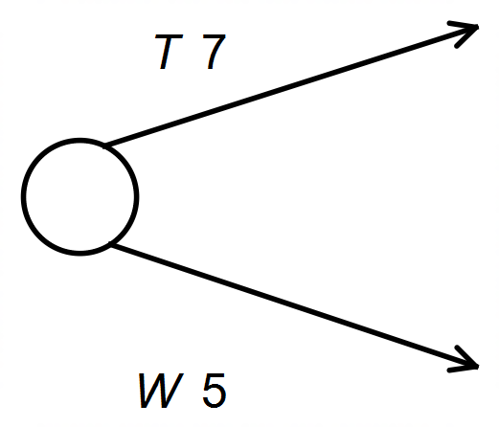

(b) Determine the critical path and the minimum completion time for rebuilding the engine.

(2 marks)

(c) Calculate:

(i) the float time for Activity Z. (1 mark)

(ii) the latest start time for Activity W. (1 mark)

(d) The part Benji ordered for Activity V has been delayed by 5 days. Explain what effect, if any, this will have on your critical path and minimum completion time. (3 marks)

**Question 17 (6 marks)**

Roz has deposited $400 000 into an annuity which will earn 5% per annum compounded annually. At the end of the first year, she intends to withdraw $30 000 for personal use. Then, for each subsequent year Roz will withdraw an amount which is 3% greater than the previous year’s amount.

(a) How much will Roz withdraw at the end of the third and fourth years?

(2 marks)

(b) How much will be left in the annuity after the 10th withdrawal? (2 marks)

(c) How many years will it take for the balance in the annuity to reach zero? (2 marks)

**End of Questions**

Additional working space

Question number: __________________

Additional working space

Question number: __________________

**Acknowledgements**

© MAWA, 2019

This examination is Copyright but may be freely used within the school that purchases this licence.

* The items that are contained in this examination are to be used solely in the school for which they are purchased.
* They are not to be shared in any manner with a school which has not purchased their own licence.
* The items and the solutions/marking keys are to be kept confidentially and not copied or made available to anyone who is not a teacher at the school. Teachers may give feedback to students in the form of showing them how the work is marked but students are not to retain a copy of the paper or marking guide until the agreed release date stipulated in the purchasing agreement/licence.

*Published by The Mathematical Association of WA*

*12 Cobbler Place, MIRRABOOKA 6…*